1. **Introduction**
   1. **Overview**

**Title: Tracing the Growth of the Global Community: A Population Forecasting Analysis**

Population forecasting is a method to predict/forecast the future population of an area. This method involves the discovery of the factors that influence present and past population increase and decrease. On the basis of assumptions concerning the future of these factors, and of other factors that are just emerging in the community, projections of fertility, mortality and migration trends are made.

* 1. **Purpose**

This method involves the discovery of the factors that influence present and past population increase and decrease. On the basis of assumptions concerning the future of these factors, and of other factors that are just emerging in the community, projections of fertility, mortality and migration trends are made.

1. **Problem definition and Design Thinking**
   1. **Empathy map**

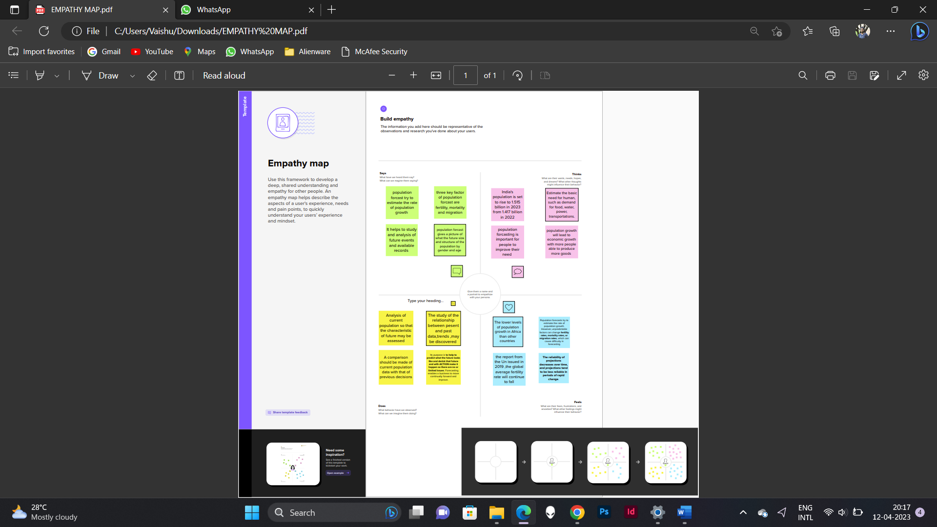

* 1. **Brainstorming map**

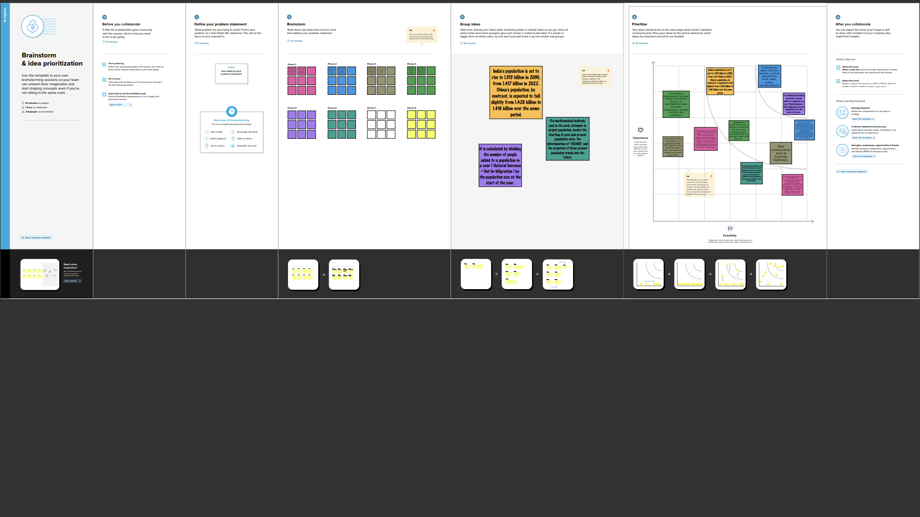

1. **Result Findings**:

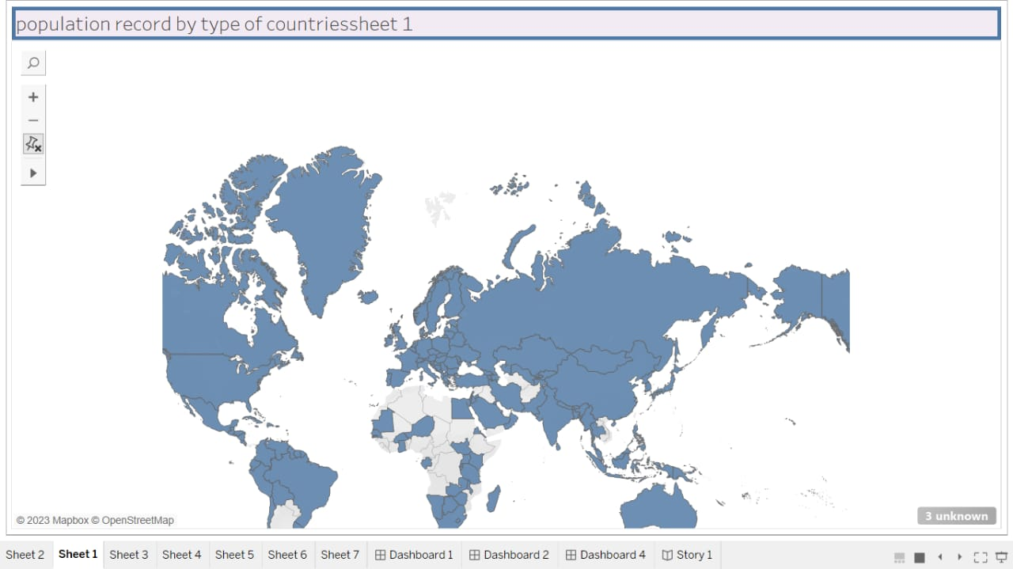

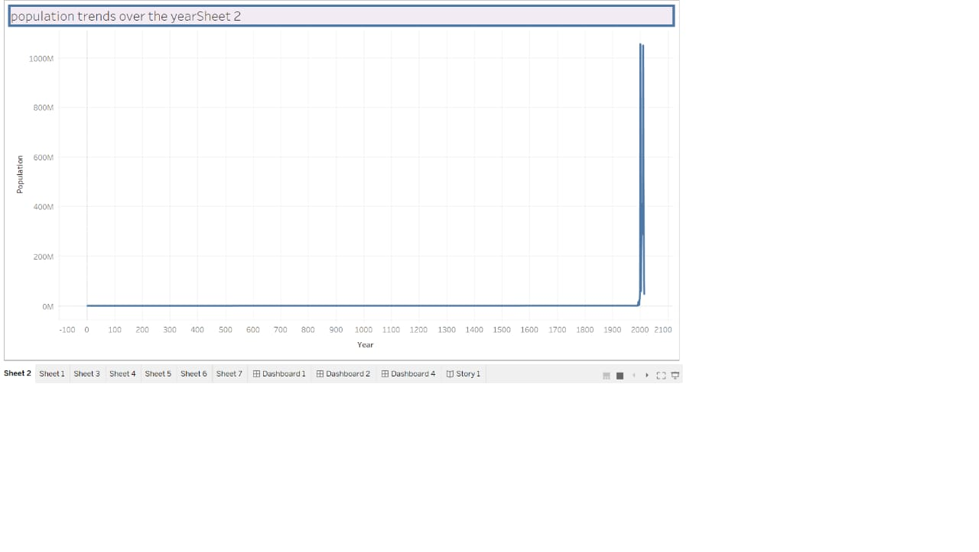

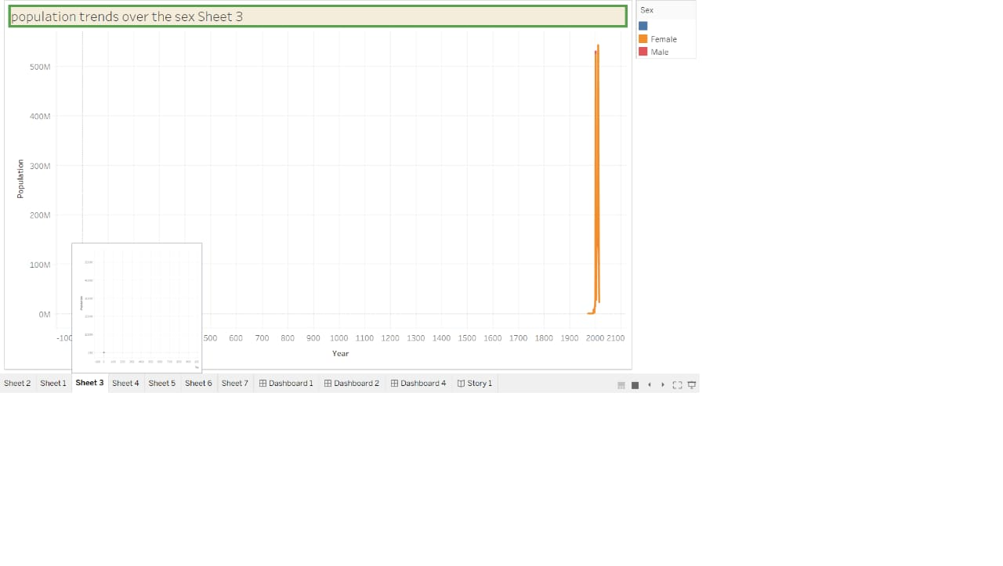

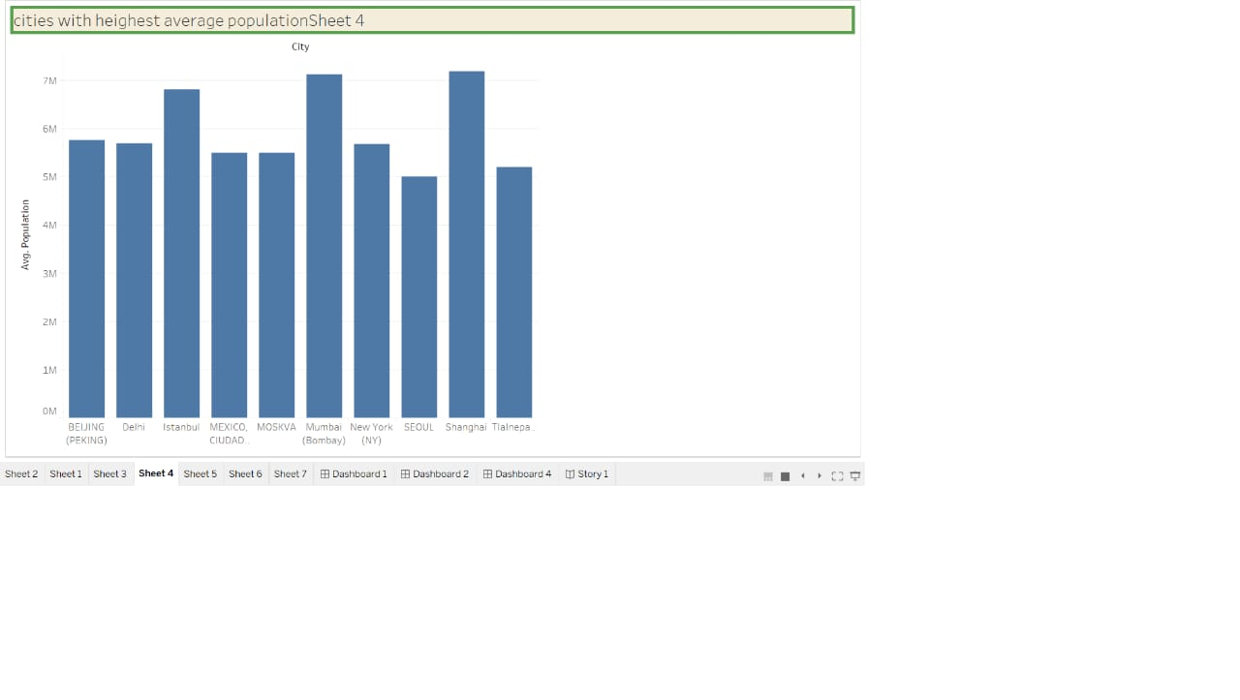

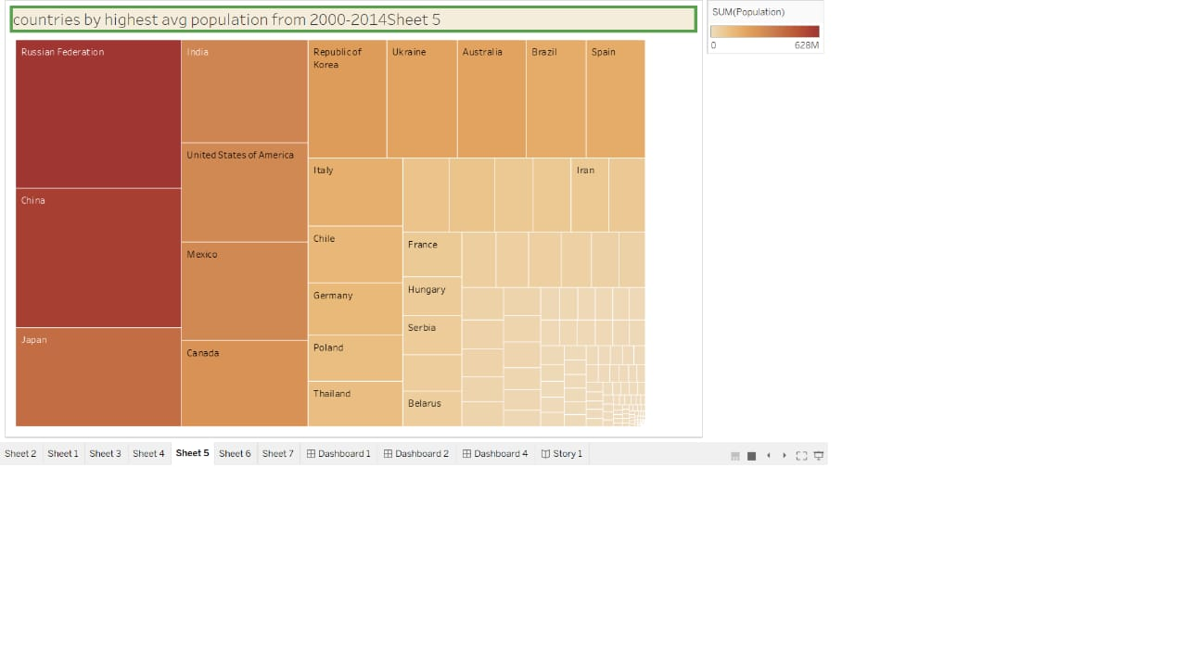

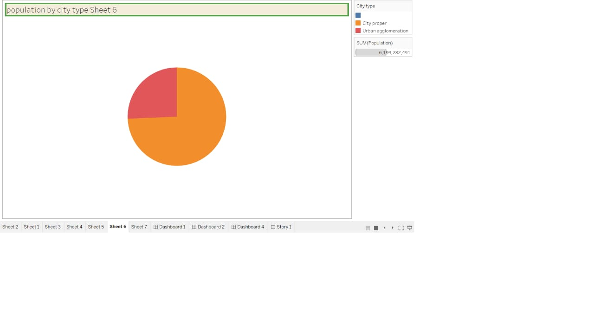

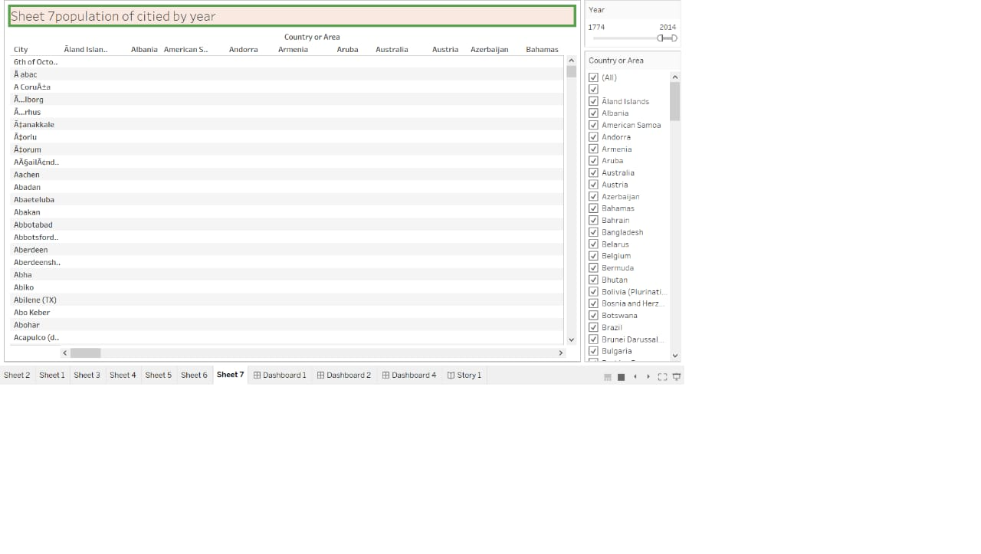

1. **Advantages**

Forecasting helps you to identify weak spots and problem areas before they actually become a problem. This allows you to get in front of those potentially problematic areas and combat them in advance, which minimises and mitigates the risks your business is exposed to.

**DISADVANTAGES:**

Forecasts are never 100% accurate. Let's face it: it's hard to predict the future. ...

It can be time-consuming and resource-intensive. Forecasting involves a lot of data gathering, data organizing, and coordination. ...

It can also be costly.

1. **APPLICATION:**

Population forecasting is defined as the method of determining the expected population for a particular design period of a water supply system with the help of the study and analysis of future events and available records

1. **Conclusion**

Conclusion: Proper demand forecasting enables better planning and utilization of resources for businesses to be competitive. Forecasting is an integral part of demand management since it provides an estimate of future demand and the basis for planning and making sound business decisions.

1. **Future scope**

The world population is projected to reach 8.5 billion in 2030 and to increase further to 9.7 billion in 2050 and 10.4 billion by 2100. As with any type of projection, there is a degree of uncertainty surrounding these latest population projections.